Firework Injury: Markov Model

Introduction and Overview of Decision Problem
This case study extend our evaluation of firework injuries using a discrete time Markov cohort model. While the decision tree we constructed yesterday provided immediate outcomes and costs for various strategies, the Markov model offers significant advantages for examining long-term health and cost impacts.
Our Markov model will allow us to capture the progression of firework-related injuries over an extended period, allowing us to consider long-term implications. By modeling injury events and transitions between different health states over time, we can better understand the chronic effects of injuries and the long-term benefits of intervention strategies.
This approach will provide a more comprehensive assessment of the lifetime health and economic impacts of the proposed strategies, considering factors such as long-term healthcare costs, changes in injury rates, and compliance levels. The Markov model’s ability to incorporate these extended horizons and recurring events will yield deeper insights into the most effective and sustainable approaches to mitigating firework-related injuries in Columbia.

1. Alive-Dead Model
We will start by constructing a simple Markov model representing just two health states: “Alive” and “Dead.” We will assume that individuals can transition between these states based on the probabilities of surviving as calculated using demographic life table data from Columbia. Once we validate that we can successfully replicate life expectancy from birth, we can begin to augment the model with firework injuries, strategies, costs, etc.

Markov Structure: Alive-Dead
The structure of the Markov model for the Alive-Dead model is shown in the figure below. Amua has a special Markov node (represented by ). The branches that lead off a Markov node designate all the Markov states (and only Markov states).
In this example, there are two health states: (1) Alive, (2) Dead. Off each health state, you can create a subtree (also called a cycle tree) that reflects those events that can occur during a cycle. The last branch at the end of each pathway will be a state transition, which defines what health state to go to for the next cycle.
 | Note that in a Markov model, outcomes are defined elsewhere – NOT at the end of the branch, but at the state.
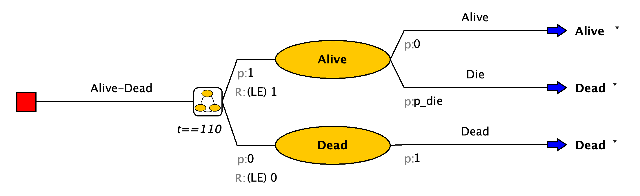

Building the Tree

Structure
After you open Amua, click Model New Markov Model.
- Save your model right at the start.
- Now select the decision node , Right-click Add Markov Chain .
- Start by developing the structure of the Markov model using Alive and Dead for the different health states. The branches of the Markov chain should correspond to the states of the model. Label the name option to the right of the decision node as Alive-Dead.
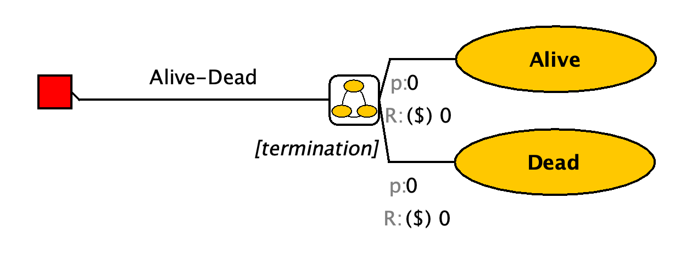
Complete the structure of the Markov model using the information above. Note: focus on adding the branches and transitions for this step; Parameters will be added later.
- When you reach the end of the branch, select the chance node you would like to turn into a state transition, right click, select Change to State Transition. This will give you the blue arrow . On the right of this arrow, you can find a dropdown menu with the different health states you specified. Select the health state this part of the cohort will transition to.
- With this button you can align the end nodes.

Cohort size and starting probabilities
- Go to Model Properties select the Simulation tab. The default cohort size is 1,000. Change cohort size to 1, so that all outputs will be at the individual level (i.e., per person).
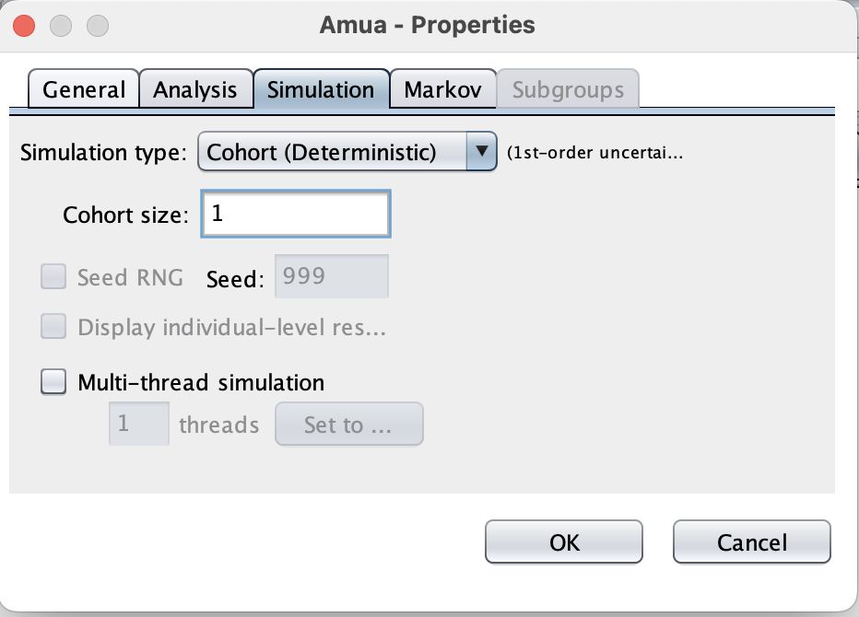
- At the Markov Chain , change the initial probabilities of health states. Since all patients start in the Alive state, change the p:0 on the left of the Local state to p:1 (see blue box below).
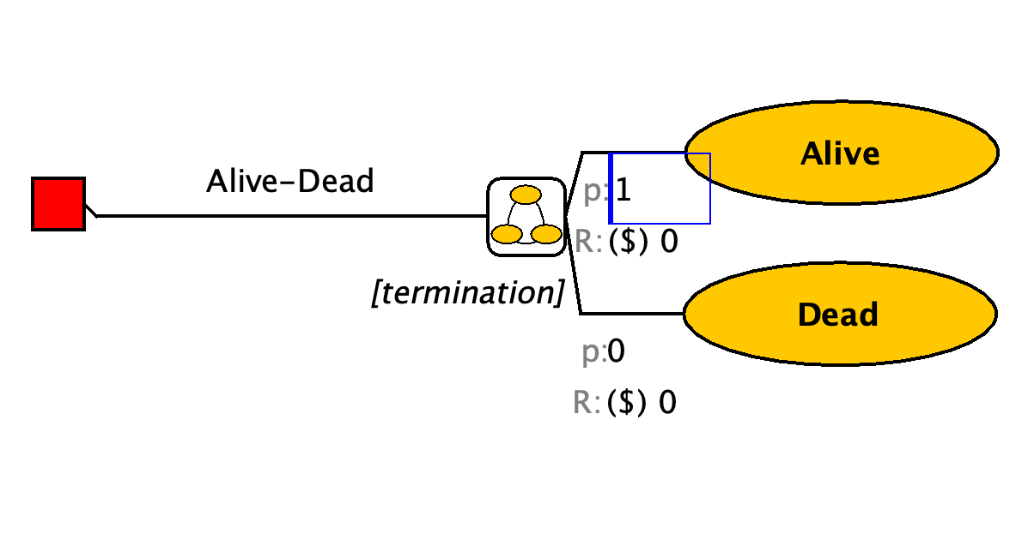

Model Parameters
First, define the following time-constant parameters for the model in the “Parameters” panel.
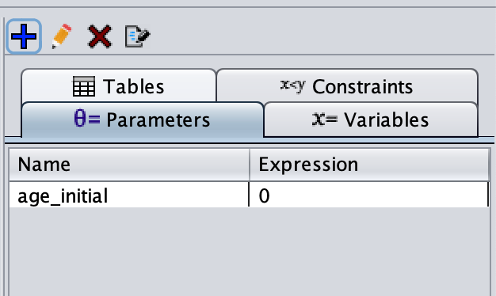
This variable tells Amua that we will model a cohort of newborns. However, we could easily adapt this to model a cohort of 20 year-olds, etc.

Transition Probabilities
The underlying transition probability matrix has the following form:
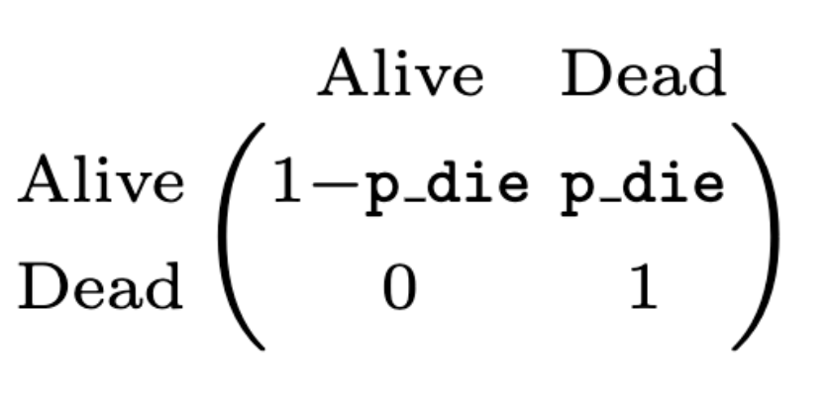
However, because we are modeling a cohort of newborns until death, we need to include death transition probabilities that vary by age (i.e., cycle) in the model. In other words, there will be a different death probability in each cycle.
 | In Amua, time-varying inputs are operationalized as variables rather than parameters.  Variables can be defined to keep track of model events and dynamically update expressions as the model runs. Thus, unlike parameters which are fixed for a given run of the model, variables can change within a simulation. Variables may change across individuals, allowing heterogeneity to be modeled, or they may change over time.
Therefore, we will define p_die as a variable that references values in a lookup table , following the steps below.
A lookup table returns the value that corresponds to a particular index. The first column in a lookup table contains the table indices, and one or more columns of lookup values can be defined. Index values must be unique and in ascending order. There are 3 lookup methods, (1) exact, (2) interpolate, and (3) truncate, for details about these methods visit the Amua Wiki on GitHub.
We first define a lookup table tbl_death to read in the age-dependent background mortality constructed from the Columbian life tables.

Download Data
Download the file titled columbia-life-table-death-probabilities.csv from the workshop website. This table contains the age-indexed annual mortality probability for Columbia. A screenshot of the first few rows of this .csv file is shown below. The index column is the age, while p_die is the annual probability of death at each age.
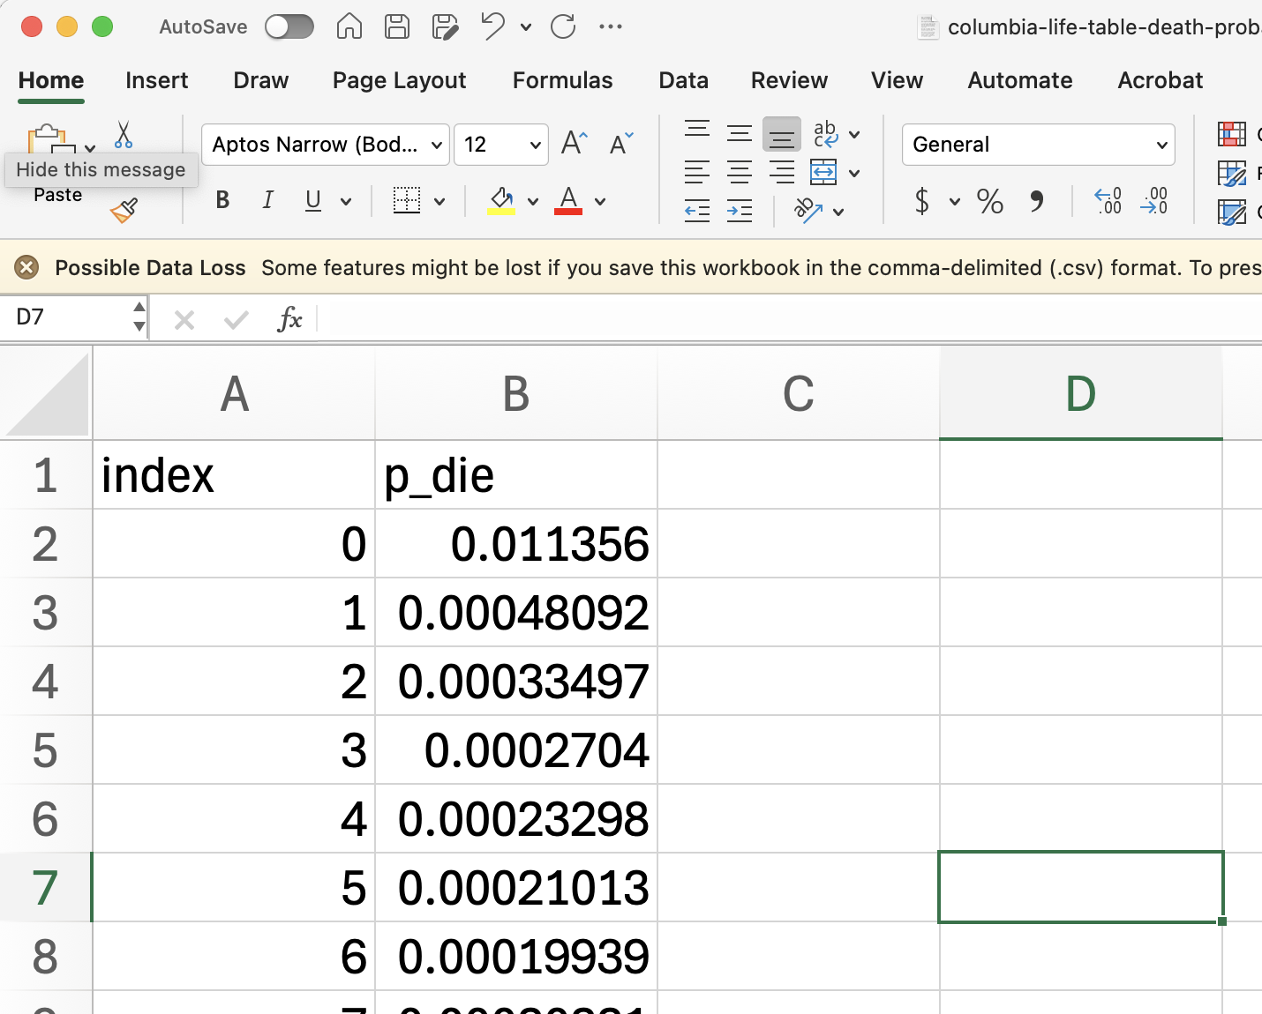
Go to the “Tables” panel, click to add a table, and you should see a “Define Table” window (see screenshot below). Click the Import button and select the downloaded .csv file to import. The table will automatically be resized to fit the imported data. The first row in the file will be used as table headers.
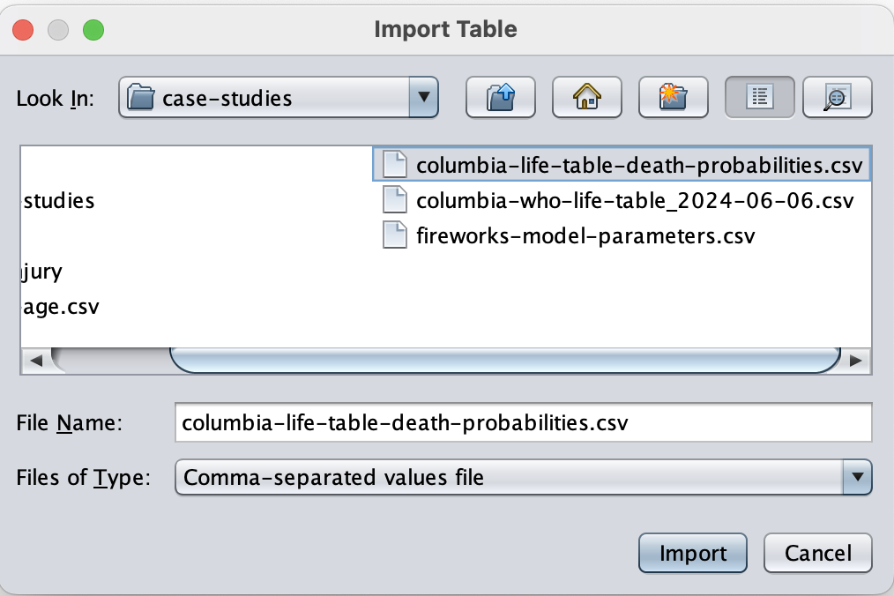
Enter “tbl_p_die” as the name for this variable. “Lookup” is the default table type (which is what we want here). Choose “Interpolate” as the Lookup Method. Click Save to apply.
Next, we can define the time-varying variable p_die (which reads from the table we just defined and operates as the background mortality probability in the current model cycle, $t$).
Make sure you create a variable and not a parameter. Under “Variables”, click to add a variable p_die = tbl_p_die[age_initial + t, 1].
The first column of a table is always used for indexing in tables. Therefore, the number “1” here will actually indicate the second column in your table as the corresponding value. You can also use the name of the column to read a value, e.g., tbl_p_die[age_initial + t, “p_die”].

 | In Amua, “t” is a built-in variable that tracks the number of cycles. It automatically updates when the model runs. For example, in the 10th cycle on the Markov model, t = 10. Therefore, in the formula “tbl_p_die[age_initial + t, 1]”, age_initial + t will equal the modeled age of the individual in cycle t, and the full formula will read the age-dependent background mortality based on the individual’s current age (instead of the initial age).  Amua defaults to a cycle time of $t=0$. Therefore, if you hit “Evaluate” the Expected Value field should calculate the death probability for a newborn as shown in the .csv lookup table.
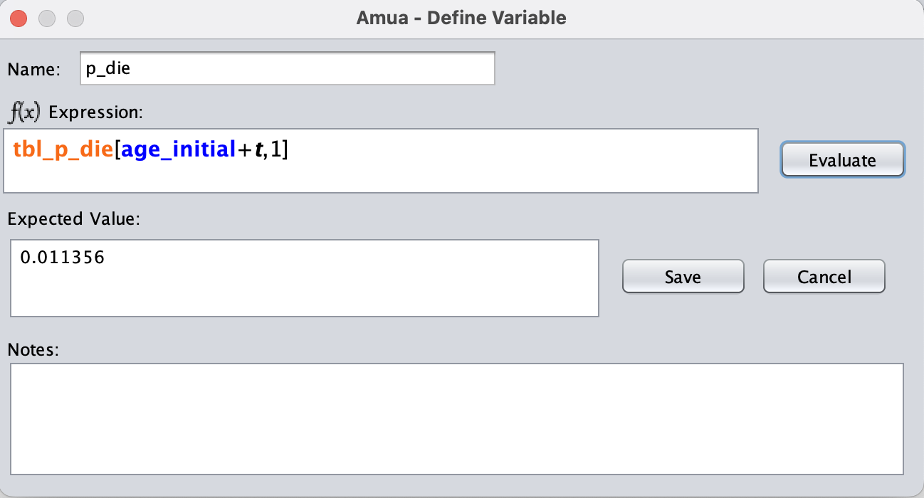
We now have all transition probabilities defined. Add these inputs to the branches of the model. Remember to add the complementary probabilities using “C” as well.

Termination Condition
- Specify the termination of the model by selecting [termination] and type t==110. This will allow your model to run for 110 cycles, then the model will terminate.
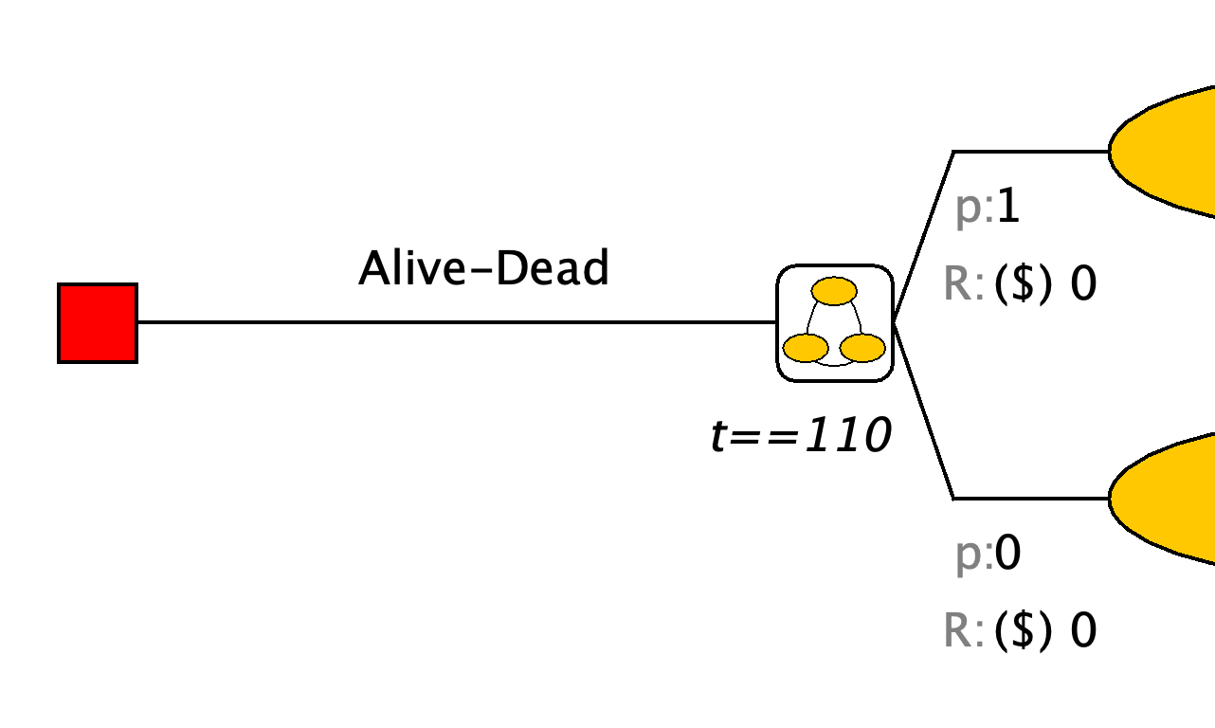

Rewards
The default reward in Amua is cost. We need to change this to have life-expectancy (LE) as a reward. Go to Model Properties select the Analysis tab and change the cost dimension to LE. Use LE as the symbol and set to 4 decimal places.
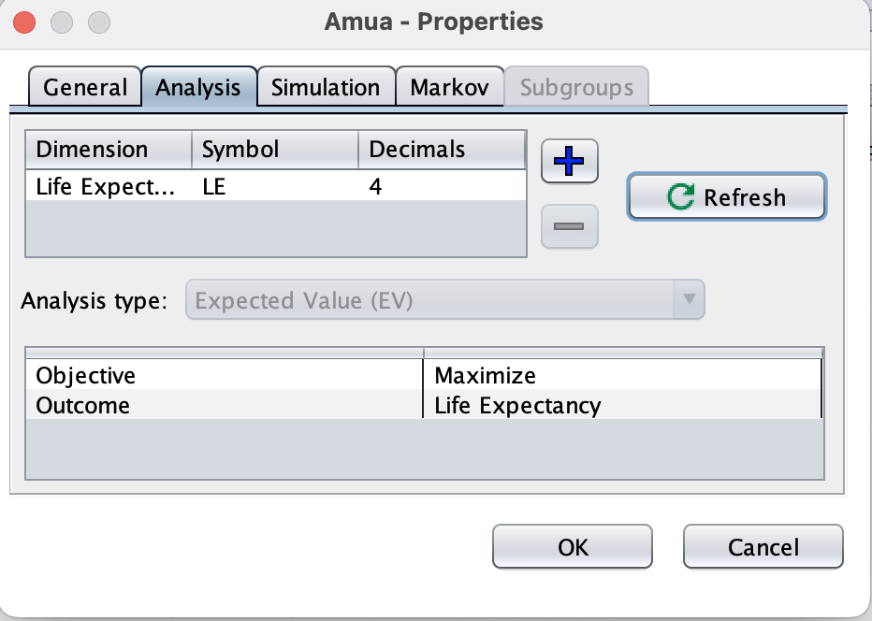
Add the life-expectancy “payoff” on the left of each health state after “R: (LE)”.
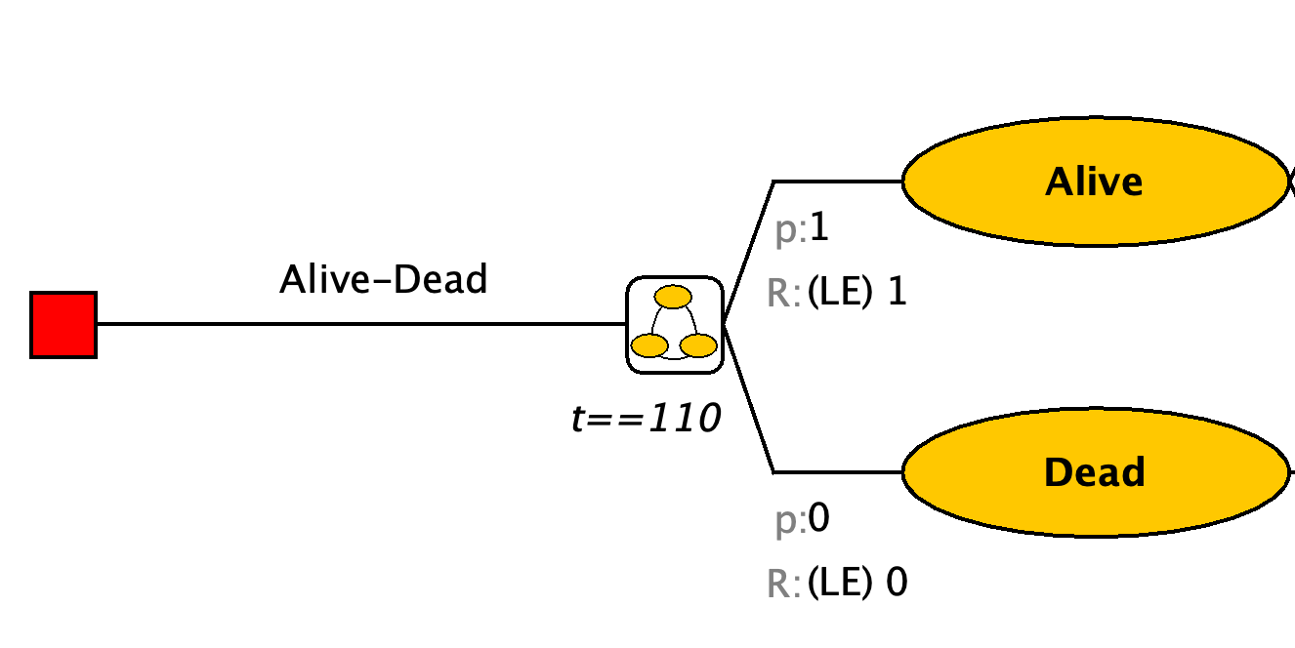
Apply Half-cycle correction. Go to Model Properties select the Markov tab and check the Half-cycle correction box. Click OK to apply.
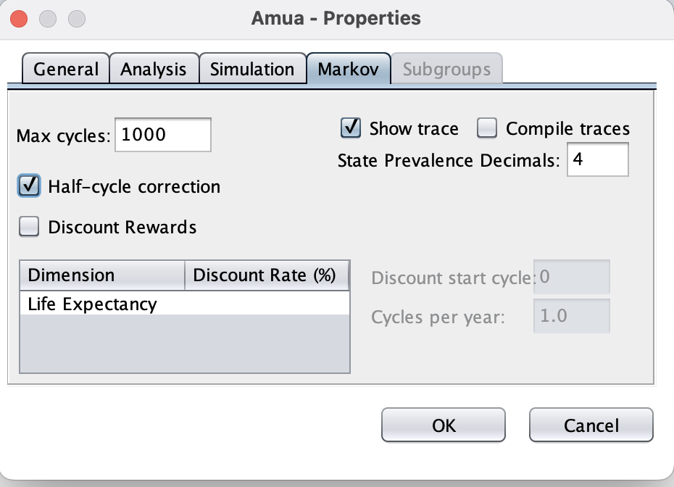
Now, we have finished constructing the Alive-Dead model. Analyze the model using a cohort simulation by clicking Run Run Model.
Run the alive-dead model and calculate overall life expectancy.

2. Firework Injury Model
Our next step is to build on the Alive-Dead model by adding in a new probability of firework injury among those who survive in each cycle. Recall the following probabilities from the Firework Injury Decision Tree case study:
Description | Base Case Value | Parameter Name
Probability of Injury | 0.0000292 | p_injury
Probability Injury is Fatal | 0.0046 | p_fatality
We will next add to the model to include two possible events:
- Firework injury
- Among those with injury, fatal firework injury.

Add Injury Chance Nodes
From the “Alive” health state, convert the blue arrow into a chance node using the change type button . From this chance node, include the chance of a firework injury. The probability of an injury should be based on a new fixed parameter called p_injury.
From the injury branch, add another chance node for whether or not the injury is fatal. Complete the structure of the model by adding transition arrows to the Alive health state if the individual either does not have an injury, or has a non-fatal firework injury. Add a transition arrow to the death state if the individual dies from their firework injury.
Your Markov tree should now look like this:
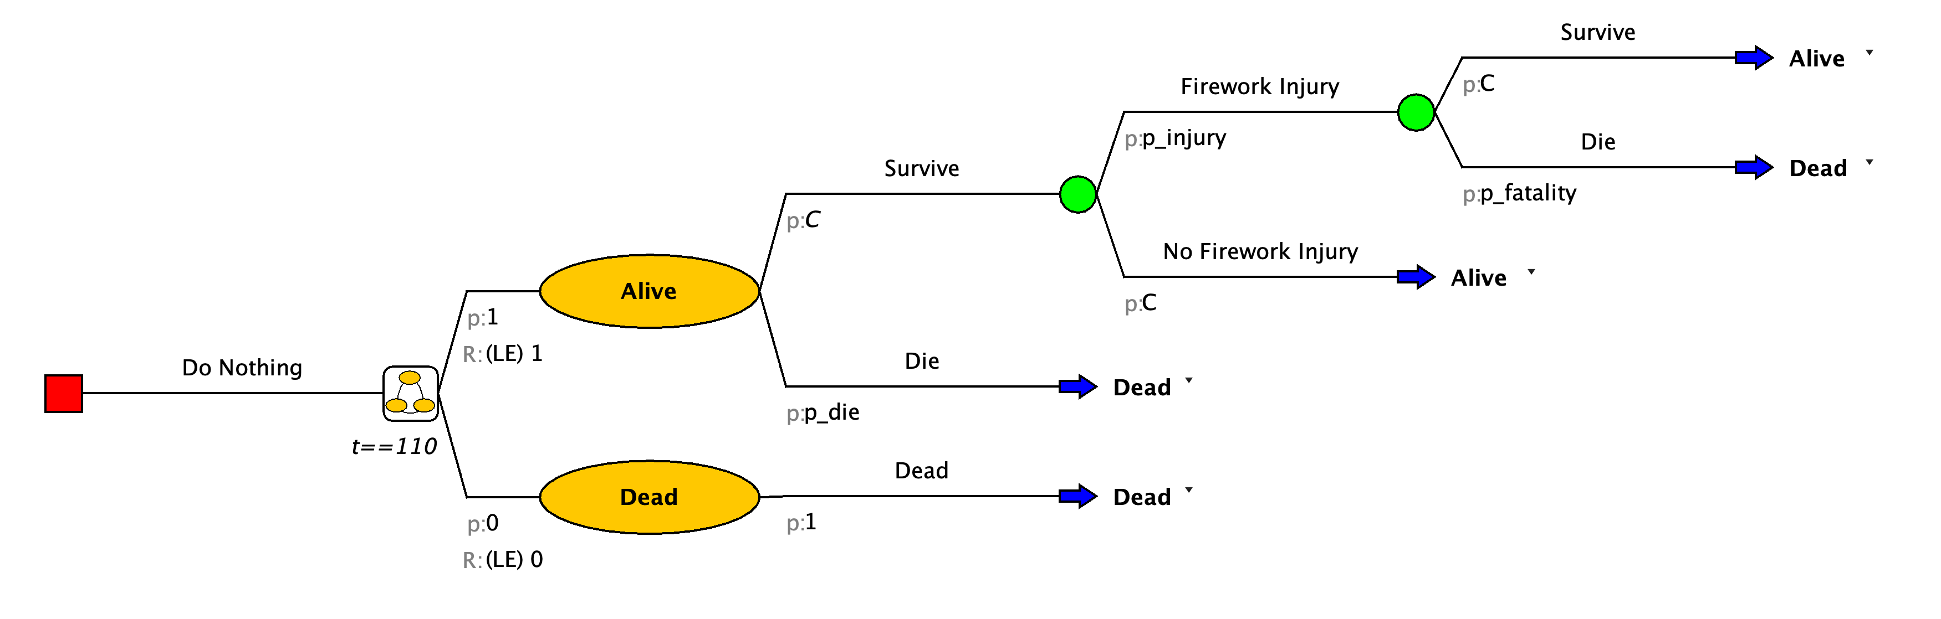

Add Injury and Fatal Injury as Outcomes
Next, add outcomes for firework injury (INJ) and fatal firework injury (FINJ) to the model (Model Properties Analysis ).
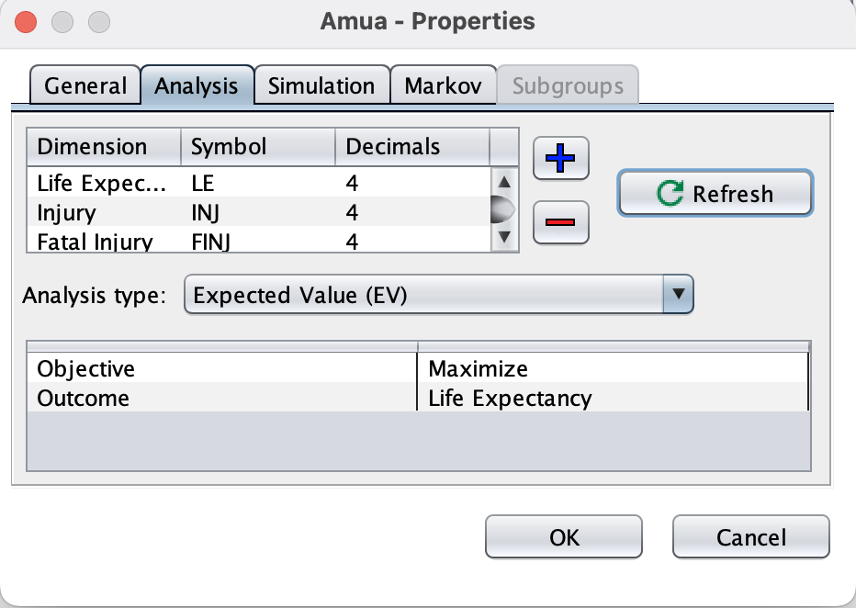
We next need to add a one-time “tracker” to record each instance where a cohort member is injured and fatally injured. We can do this by right-clicking on the chance node after “Firework Injury,” and then clicking on Add Cost.
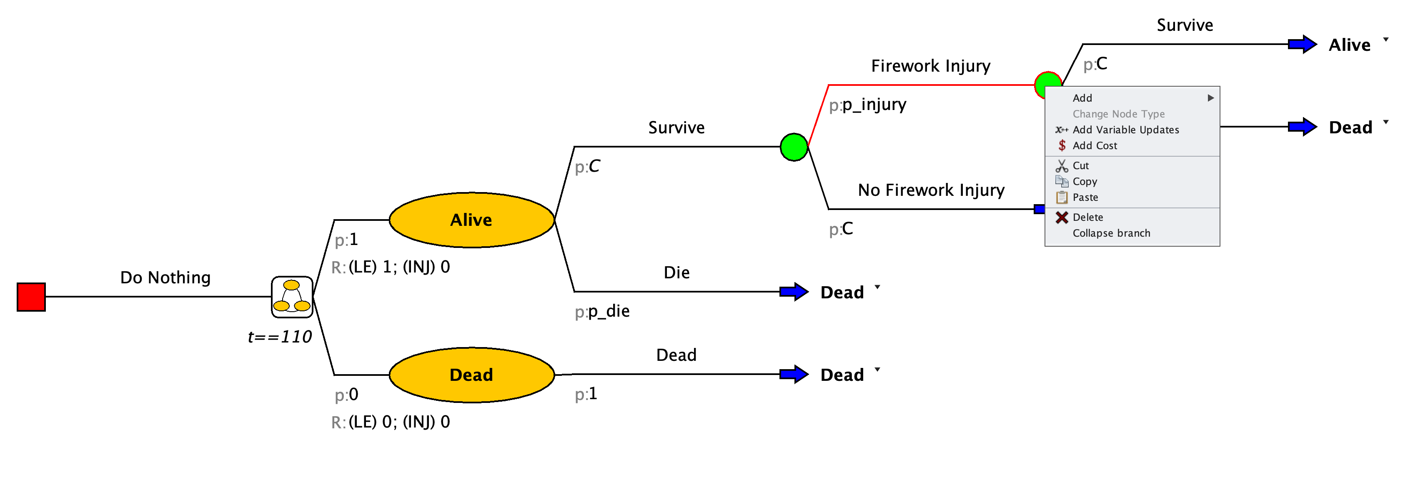
Add outcome trackers for any injury (INJ) and fatal injuries (FINJ) to your Markov tree.

Change Cohort Size
Our current model is structured for a cohort size of 1 individual. This is often useful—especially for calculating life expectancy as an outcome—but using other cohort sizes can be helpful for producing policy decision-relevant information.
We’ll now change the model so that we capture the lifetime experience of a cohort of 100,000 newborns. This will allow us to model the expected number of total and fatal firework injuries over a lifetime for a large cohort—and, eventually, to see how the total number of lifetime injuries falls under different policy options.
- Go to Model Properties select the Simulation tab. Change cohort size to 100,000.
Your life expectancy outcome (LE) will now return the expected total life years for a cohort of 100,000 people. To return a standard life expectancy outcome, you can redefine the “payoff” for the LE outcome as $1/100000$.
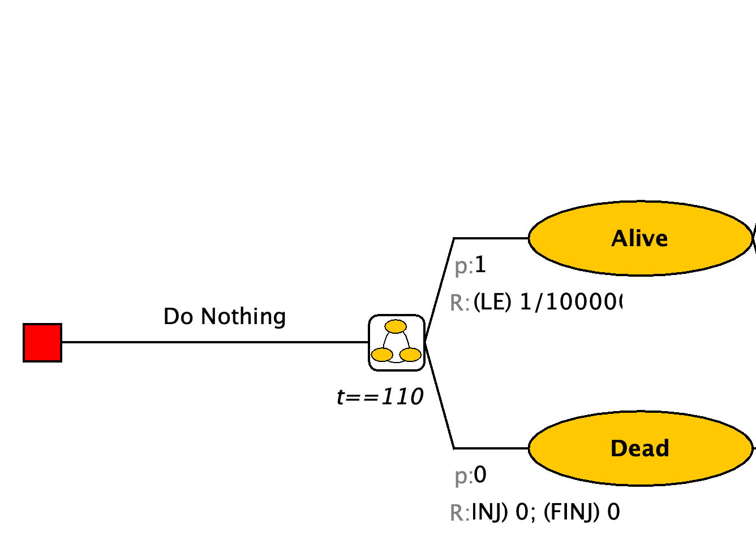

Apply Half-Cycle Correction
- Apply Half-cycle correction. Go to Model Properties select the Markov tab and check the Half-cycle correction box. Click OK to apply.

Run the Model
Verify that your model is able to run by clicking on the check model button. Once all errors have been fixed, run the model.
After you run the model, you will see expected outcomes at the bottom of the screen. This information tells us that total life expectancy is 77.04 years and there are an expected 222.07 firework injuries and 1.02 fatal injuries per 100,000 newborns in Columbia.
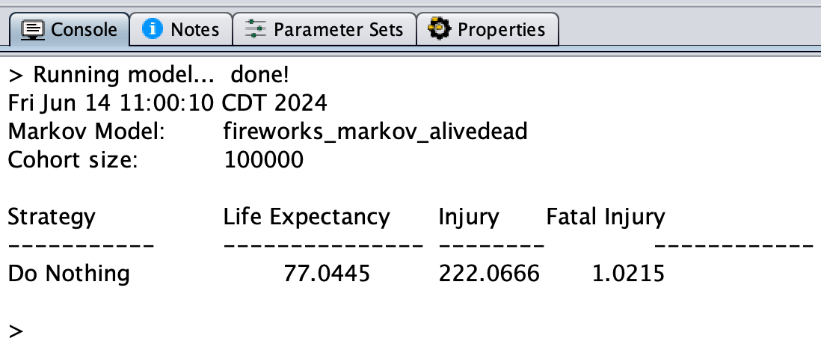
Amua will also display a new window with a figure and spreadsheet table. The figure shows the total number of people in the cohort in each health state (“Alive” and “Dead”) at each cycle of the model. The spreadsheet table contains the plotted information (in the Alive and Dead columns) as well as cycle-specific calculations for life-expectancy and injury counts.
The columns that start with Cum_ are cumulative counts of each outcome. The output below, for example, shows that at cycle $t=20$ (which corresponds to age=20 for our cohort), there are an expected 58.951 firework-related injuries in our cohort of 100,000 newborns.
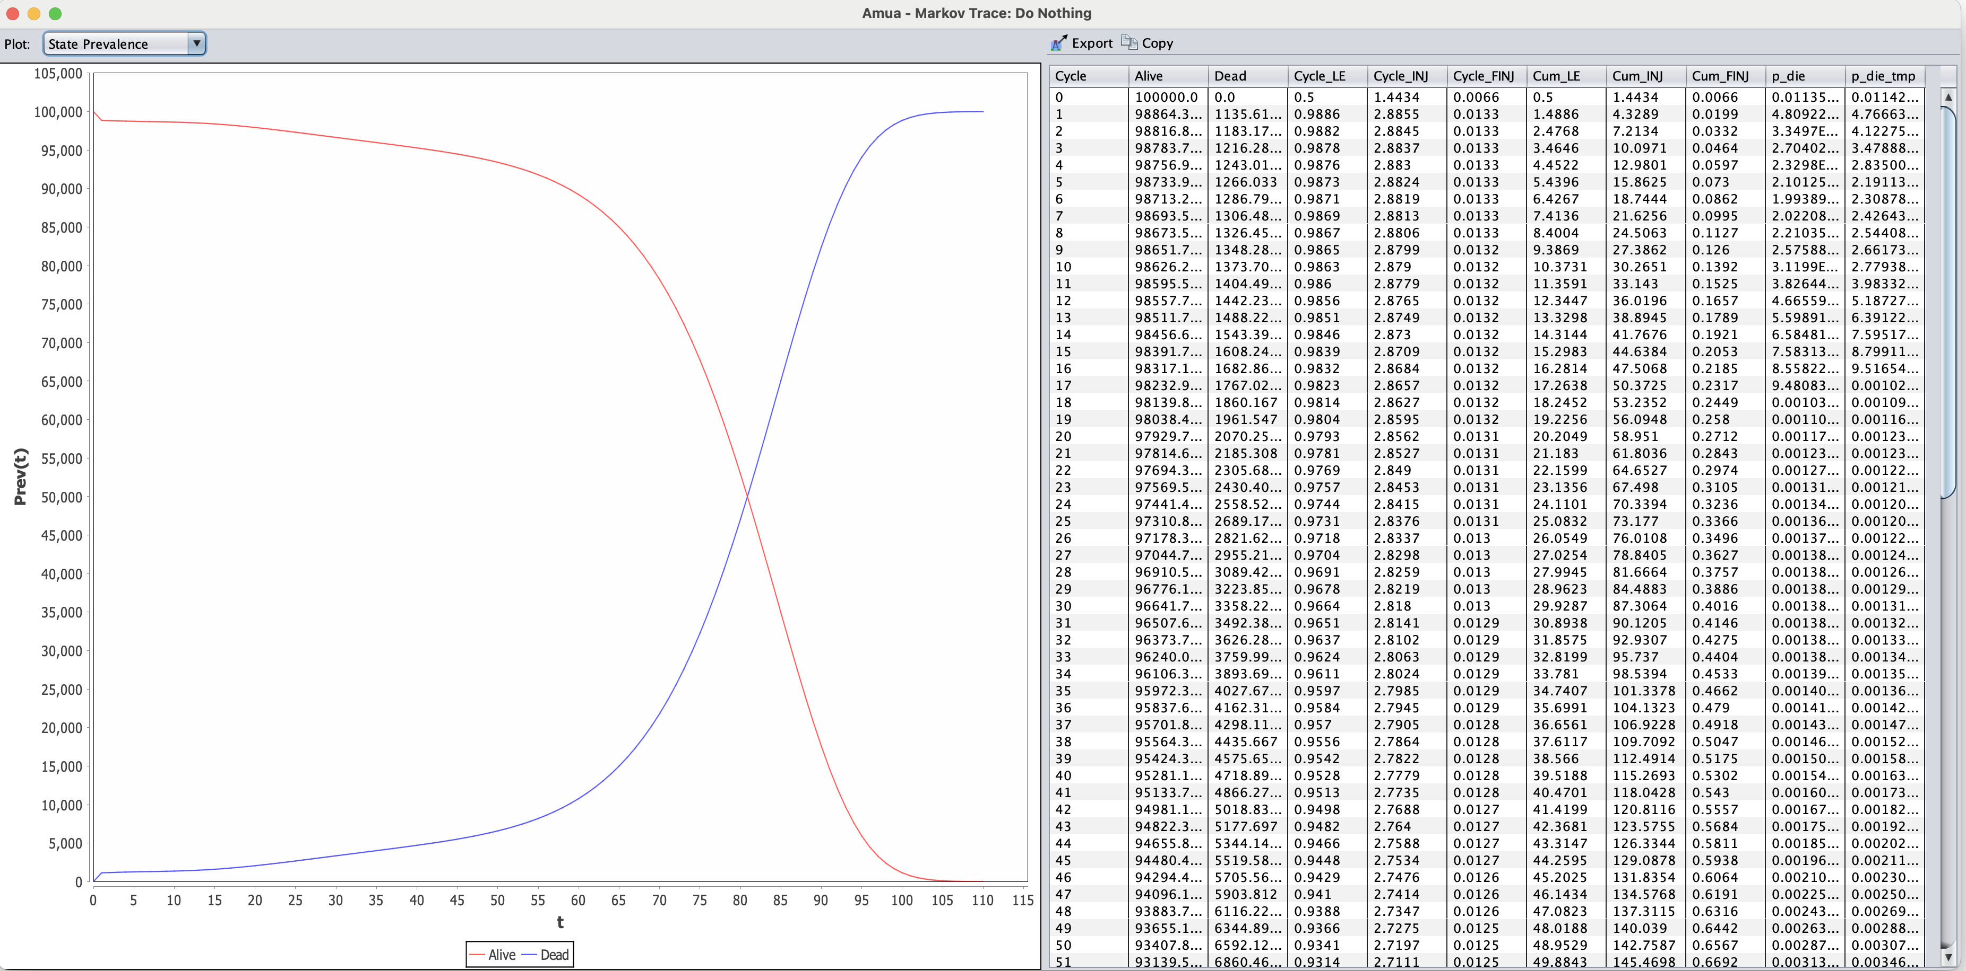

Age-Dependent Injury Probabilities
The above model was constructed with a single fixed injury probability (0.0000292). In this section, we will amend our model to allow the probability of injury to vary by age.
Our colleagues have calculated the following table summarizing the probability of firework injury by age group:
age | p_injury
0 | 0.00000759144
4 | 0.00000759144
9 | 0.00003007530
14 | 0.00005061400
19 | 0.00005131960
24 | 0.00005054530
29 | 0.00004356370
34 | 0.00003462230
39 | 0.00002484560
44 | 0.00001977440
49 | 0.00001652430
54 | 0.00001478010
59 | 0.00000575704
64 | 0.00000875774
69 | 0.00000851172
74 | 0.00000639868
79 | 0.00000474151
84 | 0.00000325532
110 | 0.00000261095

Add the Injury Probability Lookup Table
Just like we did with the age-specific mortality probabilities above, download the cases-by-age.csv data file from the workshop website.
Go to the “Tables” panel, click to add a table, and you should see a “Define Table” window (see screenshot below). Click the Import button and select the downloaded .csv file to import. The table will automatically be resized to fit the imported data. The first row in the file will be used as table headers.
Enter “tbl_p_injury” as the name for this variable. “Lookup” is the default table type (which is what we want here). Choose “Interpolate” as the Lookup Method. Click Save to apply.
Amua may also include additional blank rows when it imports the table. Before you proceed, remove all blank rows by clicking on the row, then using the button next to “Rows” (see red rectangles below).
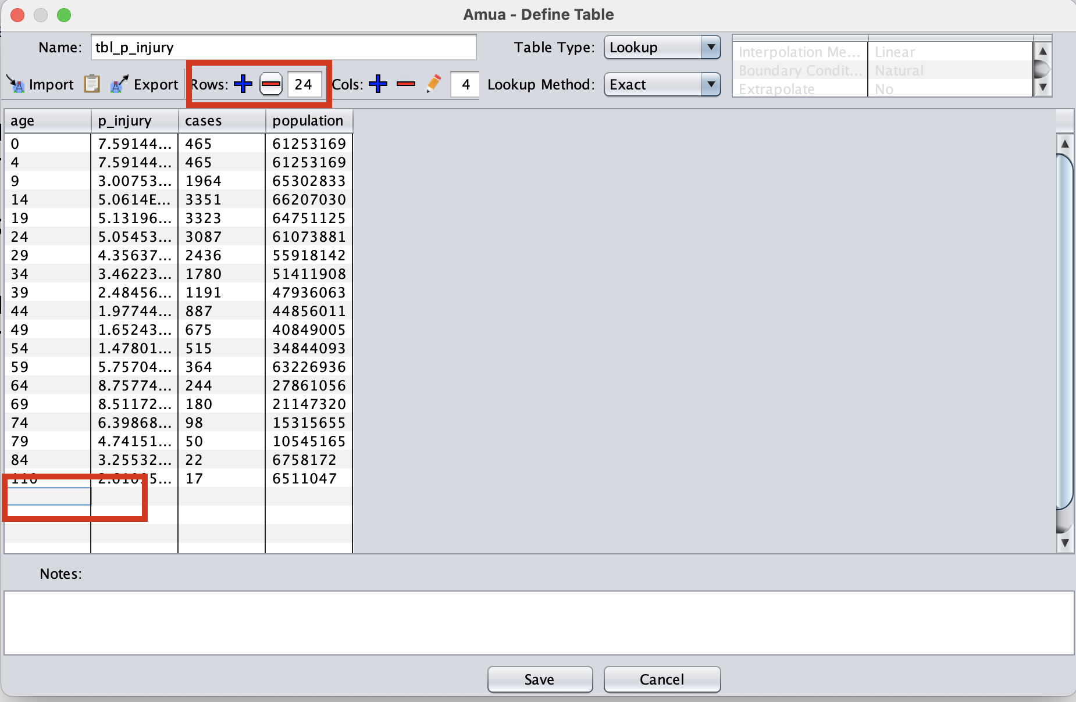

Define an Age-Specific Injury Probability
Next, we can define the time-varying variable p_injury_t (which reads from the table we just defined and operates as the background mortality probability in the current model cycle, $t$).
Make sure you create a variable and not a parameter. Under “Variables”, click to add a variable p_injury_t = tbl_p_injury[age_initial + t, 1].
Re-run the model using age-specific injury probabilities. How does the expected number of overall and fatal injuries change from when we used the fixed probabilities above?

3. Add Regulate and Ban Scenarios
As in the Decision Tree case study, please add in two additional strategies that aim to reduce the probability of injury:
Recall that you can “copy” and “paste” trees to reduce the amount of work you need to do!
Description | Base Case Value | Parameter Name
Relative risk reduction: probability of injury under “Ban” policy scenario | 0.40 | rr_ban
Relative risk reduction: probability of injury under “Regulate” policy scenario | 0.80 | rr_regulate

4. Add Long-Term Consequences
Please add in chance nodes (after initial injury) and long-term (Markov chain) health states corresponding to recovery vs. sequelae from the injury:
Description | Base Case Value | Parameter Name
Probability Injury is Severe | 0.30 | p_severe
Probability Injury is Moderate | 0.70 | p_fatality
Probability of Recovery: Mild/Moderate Injury | 0.85 | p_recover_mildmod
Probability of Recovery: Major Injury | 0.6 | p_recover_severe

