Árbol de decisiones sobre lesiones por fuegos artificiales

Introducción y visión general del problema
En Colombia, el problema de las lesiones relacionadas con los fuegos artificiales, especialmente durante las fiestas, sigue siendo un importante problema de salud pública. Los fuegos artificiales, aunque están culturalmente arraigados y son una fuente de celebración, plantean riesgos sustanciales, especialmente para los niños. Esto ha llevado a los responsables políticos a considerar diversas estrategias para mitigar estos riesgos y mejorar la seguridad pública.
El problema de decisión que vamos a considerar gira en torno al análisis de enfoques para reducir las lesiones y muertes causadas por los fuegos artificiales. Las dos estrategias principales que se barajan son (1) la prohibición total de los fuegos artificiales y (2) una reglamentación estricta, como la restricción de las licencias de venta y una aplicación rigurosa de la ley.
La prohibición total pretende eliminar la causa principal de las lesiones prohibiendo la venta, el almacenamiento y el uso de fuegos artificiales. Este enfoque pretende proteger directamente la salud pública, pero puede encontrar resistencia debido a su impacto en las tradiciones culturales y los medios de subsistencia de los vendedores.
Por otro lado, la regulación estricta implica la aplicación de controles estrictos sobre la venta y el uso de fuegos artificiales. Esta estrategia incluye medidas como la expedición de licencias de venta sólo a vendedores autorizados, la imposición de restricciones de edad y la realización de campañas de educación pública sobre los peligros de los fuegos artificiales. Este enfoque pretende reducir las lesiones al tiempo que permite un uso controlado y seguro de los fuegos artificiales.
Nuestros estudios de casos explorarán estas estrategias a través de dos enfoques de modelización de decisiones. Este estudio de caso utilizará un modelo de árbol de decisión para evaluar los resultados inmediatos y los costes asociados a cada estrategia.
Posteriormente, emplearemos un modelo de cohortes de Markov para examinar las repercusiones sanitarias y económicas a largo plazo, teniendo en cuenta factores como las tasas de lesiones, los costes sanitarios y los niveles de cumplimiento.
Mediante el análisis de estos modelos, pretendemos ofrecer una evaluación exhaustiva del planteamiento más rentable y sostenible para reducir las lesiones relacionadas con la pólvora en Columbia en la actualidad. # Model Inputs and Parameters

Injury Rates
Your colleagues have compiled the following data on gunpowder injuries by year in Columbia. We will construct a decision tree model based on injuries in the most recent year reported (2022).
Year | Cases | Population | Rate.per.100.000
2017 | 1,778 | 47,419,000 | 3.75
2018 | 1,477 | 48,259,442 | 3.06
2019 | 1,378 | 49,269,676 | 2.80
2020 | 1,504 | 50,407,437 | 2.98
2021 | 1,694 | 51,177,378 | 3.31
2022 | 1,510 | 51,826,932 | 2.92

Injury Types and Consequences
We will assume that reported injuries fall into three major categories:
- Minor Or Moderate Injury: First-degree burns, which may cause pain, redness, and minor swelling. This category also includes second-degree burns that cover a more significant portion of the body and involve blisters, pain, and potential infection risk
- Major Injury: third-degree burns or severe trauma that affects deeper tissues and can lead to significant complications.
- Fatal Injury
 | There are very likely many minor and moderate injuries that go unreported in official statistics. For this case study, we will assume that severe injuries are 30% of reported injuries.
Description | Base Case Value | Parameter Name
Probability of Injury | 0.0000292 | p_injury
Probability Injury is Severe | 0.30 | p_severe
Probability Injury is Fatal | 0.0046 | p_fatality
We will also assume that a small percentage (15%) of individuals with mild/moderate injuries experience long-term consequences (i.e., 85% recover), while the majority (60%) of those with severe injuries do not fully recover and experience long-term complications.
Description | Base Case Value | Parameter Name
Probability of Recovery: Mild/Moderate Injury | 0.85 | p_recover_mildmod
Probability of Recovery: Major Injury | 0.6 | p_recover_severe

Strategies and Impact
When the mayor of Bogota banned the sale of fireworks in 1995, fireworks-related burns fell by 62%, from 204 in the 1994-1995 Christmas season to 77 during the 1995-1996 season. We will assume a similar 60% relative risk reduction under the “Ban” scenario.
By comparison, we will assume that stricter regulation will reduce firework injuries by just 20%. We will examine the sensitivity of our findings to these assumpions later in the case study.

Exercises

1.1. Build a “Do Nothing” Strategy
Construct a decision tree in Amua for a “Do Nothing” strategy. Your tree should work through the following chance nodes:
- Injury vs. No Injury
- Fatal injury vs. non-fatal injury
- Mild/Moderate vs. Severe injury
- Full recovery vs. Recovery with injury sequelea
Please use the parameter names and values supplied above in the construction of your tree.

1.2. Add Outcomes
Amua defaults to cost outcomes. Please remove the cost outcome and define a new primary outcome based on injury. In other words, the outcome “payoff” should be 1.0 if an injury occurs, and 0 otherwise.
 | You can edit the outcomes by clicking Model Properties Analysis:  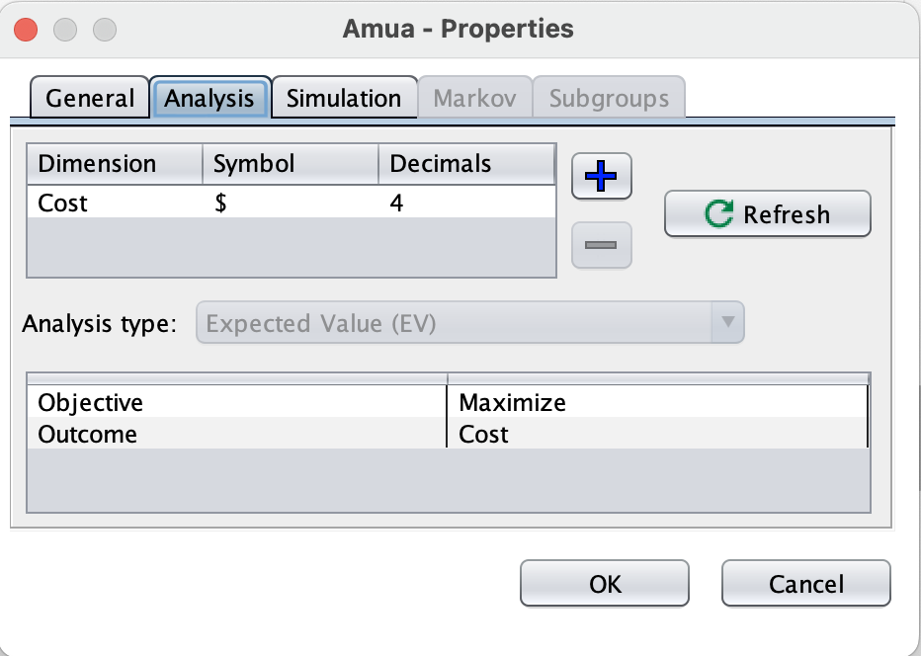

1.3. Ensure Your Model Calibrates to Observed Injury Totals
Run your initial decision tree using a cohort size of 51,682,692 (2022 population of Columbia). Verify that the total number of firework injuries closely matches the reported total of 1,510.
You can enter the cohort size by clicking Model Properties Simulation:
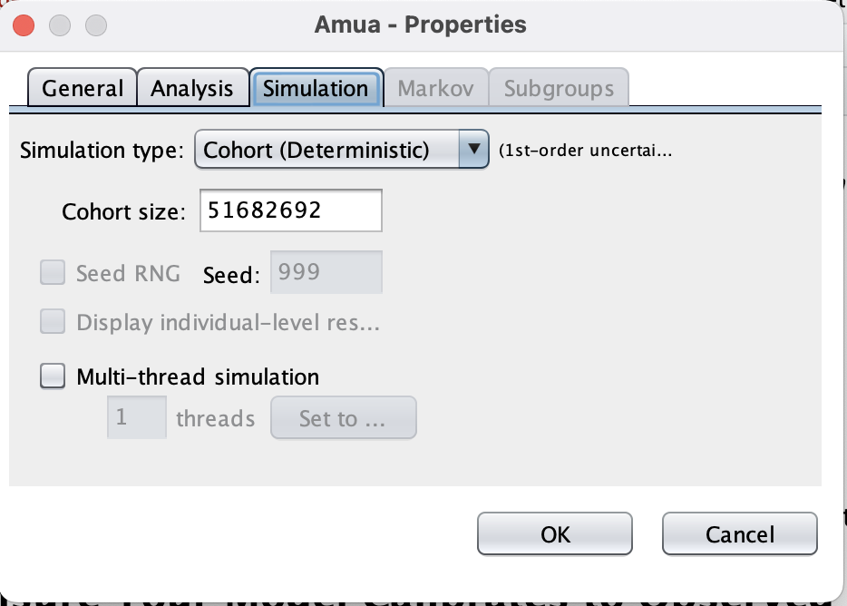

2.1. Include Additional Policy Scenarios
Create a duplicate version of your “Do Nothing” tree to construct separate branches for the “Ban” and “Regulate” scenarios. Under each, the probability of injury should be modified by a relative risk reduction parameter with values set based on the text above and the table below.
Description | Base Case Value | Parameter Name
Relative risk reduction: probability of injury under “Ban” policy scenario | 0.40 | rr_ban
Relative risk reduction: probability of injury under “Regulate” policy scenario | 0.80 | rr_regulate

You can copy and paste the “Do Nothing” branch by right-clicking on the first chance node and selecting “Copy.” You can then paste a copy of the entire tree structure on the red decision node .

2.2. Add Additional Outcomes
Add additional outcomes based on each injury type (mild/moderate, severe, fatal). Use your decision tree to project injuries overall and by type under each strategy. Use your results to fill out the table below. Each cell should have calculated counts of the number of each type of injury under each strategy.
Strategy | Any Injury | Mild/Moderate | Severe | Fatal
Do Nothing
Ban Fireworks
Regulate Fireworks

Source: “Antanas Mockus: The Prohibition of Fireworks in Bogotá Sequel,” Harvard Kennedy School Case Study. Available fromhttps://case.hks.harvard.edu/antanas-mockus-the-prohibition-of-fireworks-in-bogota-sequel/

